AtGuider2 Reference (V1.0) Rick McAlister 09/18/18

**Overview:**

AtGuider2 is a Windows console app that assists with the TheSkyX process for calibrating a guide camera. Before running AtGuider2, a user must have TheSkyX configured with imager and guider FOVI’s and have successfully performing automated image links (e.g. T-Point runs). Once launched, ATGuider2 will find an appropriate star near the current pointing position, center the guider camera on the star, adjust the exposure, then calibrate. AtGuider2 can run with or without a rotator. AtGuider2 does not calibrate an AO, but it leaves TSX in a state where one could easily do so.

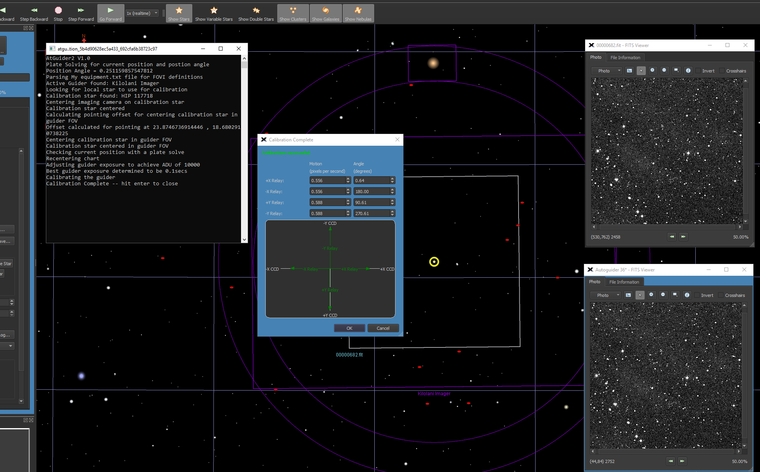

**Notes:**

1. At Rev 1.0, AtGuider2 is not particularly robust: a failure at any stage will be ignored or throw an error and exit. See notes below on getting it right.
2. AtGuider2 relies on having the Camera and Guider FOVI’s set up correctly and accurately. The TSX forums contain lots of tips to get it right. As AtGuider2 uses plate solutions (image linking) to position the guider FOV over a target star, incorrectly configured FOVI’s will mess the whole thing up.
3. AtGuider2 reads FOVI information from the Software Bisque “My equipment.txt” file in the “Field of View Indicators” directory. TSX uses configuration information from this file upon launch, but it does not update any changes until the TSX session is ended. Therefore, upon creating or modifying any FOVI, the user must close TSX then relaunch in order that AtGuider2 can acquire any FOVI updates, including changes as to the active FOVI selection.
4. When creating an FOVI for AtGuider2 to use, the main camera FOVI must be “Element 1” and the guider camera FOVI must be “Element 2”. At2Guider doesn’t care what you name them. Before running AtGuider2, the FOVI to be used must be the sole FOVI that is selected as active in the FOVI list. Properly done, the FOVI of the imager/guider combination should show on the star chart. (See Note 3).
5. For positioning, AtGuider2 uses only the FOVI’s and automated image linking. As such, the use of a rotator doesn’t matter – as long as the FOVI’s are set up correctly.
6. If TSX cannot perform an automated image-link then the procedure will fail. However, if TSX can run T-Point, then AtGuider2 should work fine as the settings are the same.
7. To automatically find target stars, AtGuider2 uses the same built-in search as the @Focus2 function. This simplifies the installation process a bit, but it means that the selected stars might be a touch too bright for optimal calibration (i.e. saturated). The other possible problem this allows is that if the telescope is pointing too close to the meridian, target stars could be selected that require a meridian flip. Solutions to both these issues (as well as AO support) may be incorporated in the future, if things work out.
8. AtGuider2 has been tested with the simulators, on a fixed and on a rotating imaging system. The latter were mounted on a MyT and MX+ respectively and used Direct drive for guiding through off-axis guide cameras (STX and STI). Things could be different on different systems. I’ve done my best to note those things that must be configured but I certainly could have missed something important that I normally set up on my systems but others do not. Me culpa prae.
9. AtGuider2 does not try to adjust any of calibration set-up parameters at this time. If calibration is failing because of insufficient movement, then increase the calibration time/distance in the set-up (hot pixels will rarely, if ever be a problem when targeting stars this bright). If the calibration is failing because of too much movement, then cut down on the calibration time/distance.
10. In the telescope set up, “Always keep telescope crosshairs visible on star chart” must be set to “Yes”. If not, the star selection search might not be so local.

**Requirements**:

AtGuider2 is a Windows console application, written in C#. The application runs as an uncertified, standalone application under Windows 7, 8 and 10.

**Installation**:

Download the AtGuider2_Exe.zip and open. Run the "Setup" application. Upon completion, an application icon will have been added to the start menu under "TSXToolKit" with the name "AtGuider2". This application can be pinned to the Start if desired.

**Support:**

This application was written for the public domain and as such is unsupported. The developer wishes you his best and hopes everything works out. If you find a problem or want to suggest additional features, please contact the author and he'll see what he can do.